We're finally back to face-to-face organising and have renewed our support for some great young people and initiatives from New Zealand to Dorset!

What we've been up to...
We've given support and funding to some incredible applicants so far this year: ranging from a young man starting his own community initiative to reduce digital poverty, to a young woman training to become a qualified music therapist to support vulnerable people. We are continuing to meet every month via Zoom or in person to run the charity, speak about fundraising and of course, to develop our plans for 2022.
Here's a quick look at what's been happening:
- We've supported an applicant to combat digital poverty in his area by providing three tablets to volunteers to enable them to actively support the mutual aid group he has continued to run beyond lockdown. You can read more about his work
here.

- We've built a new relationship with
Direct Theatre School
where Yolanda studied drama while at school. They have presented "The Yolanda Moore Award" for the best student in 2021 and will continue to do so in future years. We are hoping to support a student of the theatre school to take their next step.
- We have funded a young person to attend a conservation and environmental expedition to Honduras, which will help them pursue their dream career as an Environmentalist.
- We've provided funding and support for 5 successful applicants so far and have renewed our partnership with 3 schools in Wānaka, New Zealand to help provide access to a range of snow activities for disadvantaged children.
- So far we have shared over £6000 of our fundraised pot with applicants as well as providing extensive mentoring support for a number of young people, including previous applicants as they continue to pursue their futures.
- We continue to receive a number of new applications as young people, now more than ever, continue to struggle in the pursuit of their goals.
Check out our website
www.TYMF.co.uk

for a full round-up of all of the exciting news and all kinds of other bits and bobs.

See what we're up to

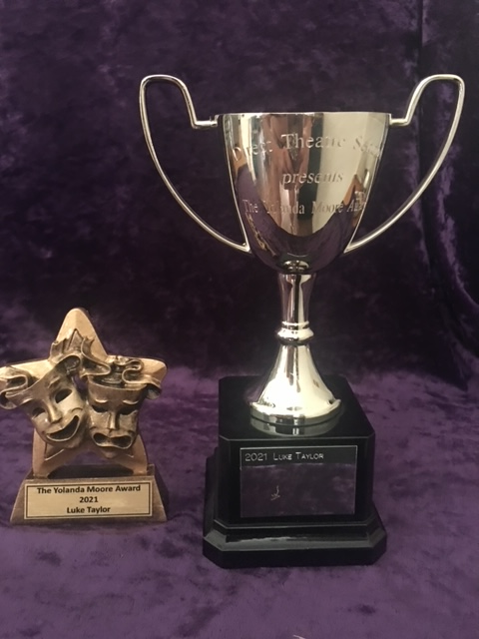
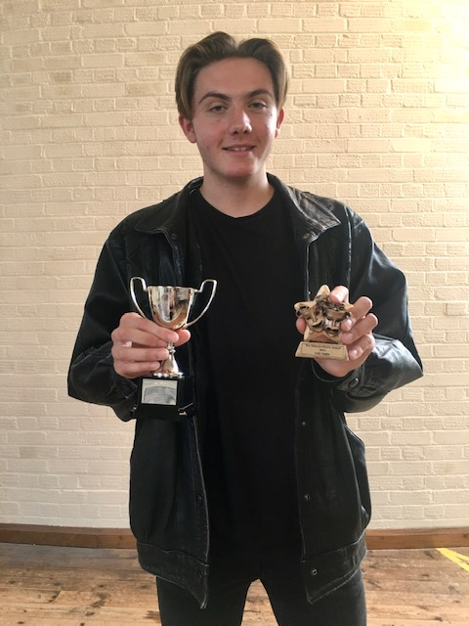

Direct Theatre School

have shared these brilliant pictures of the awards and winning student this year. We are hoping to support a student of the theatre school to take their next step and look forward to our future celebrating special talent every year.

We've renewed our support for three schools in Wānaka, New Zealand to allow 60+ children to enjoy skiing and mountain activities!

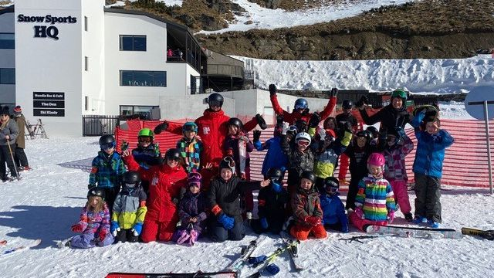
It was a pleasure to support schools from Wānaka, a place very special to Yolanda, to allow families the opportunity to enjoy snow activities with their classmates.

"We wish to thank your foundation for the support received for our 9 year old son in being included in this year’s 1 Day Cardrona Ski/Snowboard experience at his school.
Our family wouldn’t have been able to afford this for him and both my husband & I work so we would not have been able to take the time off work to be with him in the snow. It means so much to us that he will be able to experience this and we thank you all so very much for the blessing for our son!"
- Parent at Wānaka Primary School

How can you help?
We're always looking for charitable friends to help us widen our network, whether you can offer some mentoring support from your industry or could provide vitally useful work experience for one of our awardees. Just get in touch to let us know you'd be interested in being added to our books.
We are also always on the look-out for get up and go-ers who are planning on raising some money for charity, we'd love if you chose us as your charity of choice to help us continue to fund these inspiring young people. If you have any ideas or would like to choose us to support in the next 12 months, please get in touch we'd love to know your plans!

Find out more and donate

DID YOU KNOW?
You can officially elect us as your 'Amazon Smile' charity of choice! AmazonSmile is a simple and automatic way for you to support a charity of your choice every time you shop, at no cost to you. AmazonSmile is available at
smile.amazon.co.uk

on your web browser and can be activated in the Amazon Shopping App for iOS and Android phones. When you shop AmazonSmile, you’ll find the exact same low prices, vast selection and convenient shopping experience as amazon.co.uk, with the added bonus that AmazonSmile will donate a portion of the purchase price to your selected charity. We have raised £100 via Amazonsmile so far!

100% of our donations go directly towards funding the aspirations of the young people who successfully apply for our help. We do not use any donated funds to support our administration costs which are covered privately.

