Wishing you all a very...

Happy 2020!



Whether you're groggy from a great start to the New Year or already getting those resolutions on way (you brave soul), we'd love to wish you a very Happy New Year. We made some great advances in the last year as a charity and we're working hard to keep growing in the New Year. As always, if you know of a brilliant young person who would benefit from some help please get in touch or direct them to our
Apply page

.

Make us your charity for the year!
If you've decided to get some good karma this year, running, cycling, climbing or launching yourself from a plane (parachute attached!) or any other brilliant idea, we'd love to be your charity for this year. You can elect us as your charity and we'll be on hand to give you all the marketing and fundraising support you need, whether it's acting as your online cheerleader or sending you some posters and flyers to help you tell others what we do. All of your donations go directly towards funding young people - all other costs are funded externally.
You can use our preferred partner Virgin Money Giving who will manage the gift aid or your preferred fundraising platform. You can find out more here:
www.tymf.co.uk/get-involved

Check out our website for a full round-up of all of the exciting news and all kinds of other bits and bobs.

Find Out More

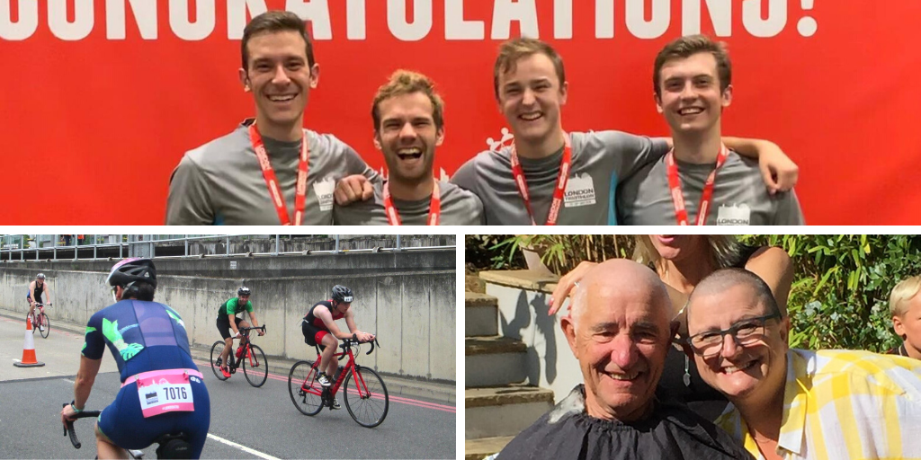
Last year we had some amazing fundraisers who have helped us fund ambitious young people to overcome their barriers and achieve their goals, we'd love to welcome more this year as we reach out to more young people and help achieve more goals. If one of your New Year resolutions is to help someone this year please consider raising money for The Yolanda Moore Foundation. You can see what our incredible supporters have been up to and get some inspiration here:
http://www.tymf.co.uk/get-involved/

